Early Liver Disease Detection Project Submission
This template helps you capture and share screenshots of your code and results for each task.

Instructions
- Insert screenshots showing both the code and its output for each task.
- If one screenshot cannot clearly show both code and output, use two screenshots placed one after the other.
- Ensure all screenshots are readable so peers can review your work easily.

Creating my model, step by step

Task 1: Analyze the dataset
Activity number | Activity name | Screenshot of both the code and output
1 | Load the dataset:  - Display the message ‘Dataset loaded successfully!’ | 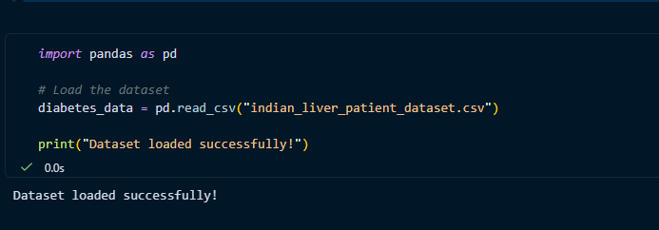
2 | Print total number of rows | 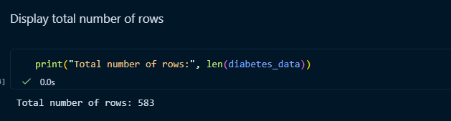
3 | Print top 5 rows | 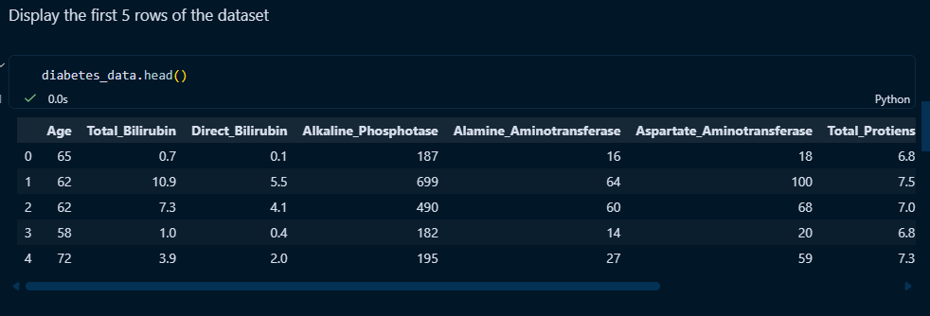

Task 2: Identify the features and target columns
Activity number | Activity name | Screenshot
1 | Identify the target (y) column:  - Print all columns  - Print the target column name  - Print the target column values | 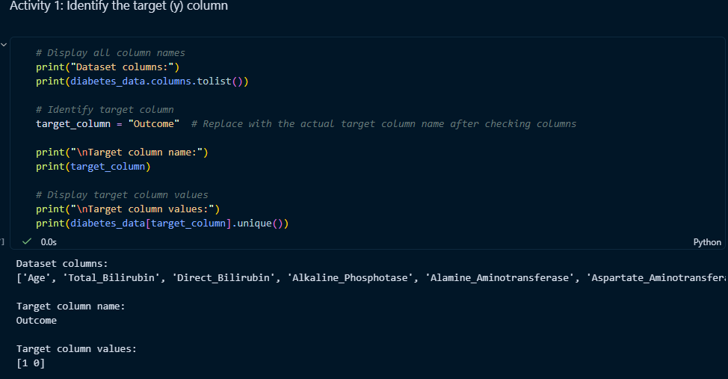
2 | Identify the features (X) columns:  - Display a message ‘Features (X) columns identified:’  - Print the number of feature columns  - Print the feature column names | 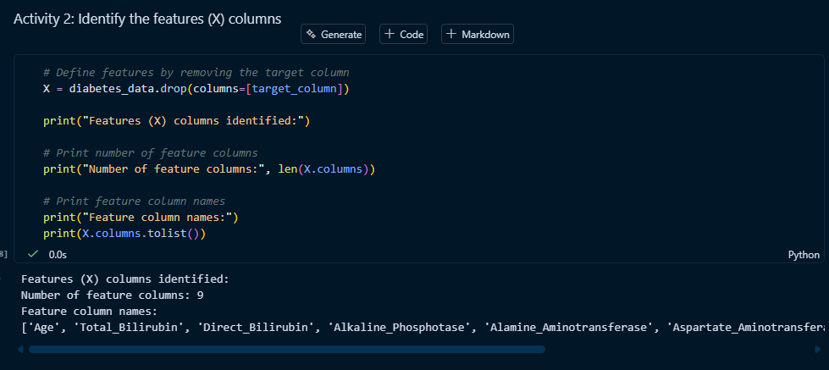
3 | Split the data into test and train sets:  - Print the training set size  - Print the testing set size  - Print the training features shape  - Print the testing features shape | 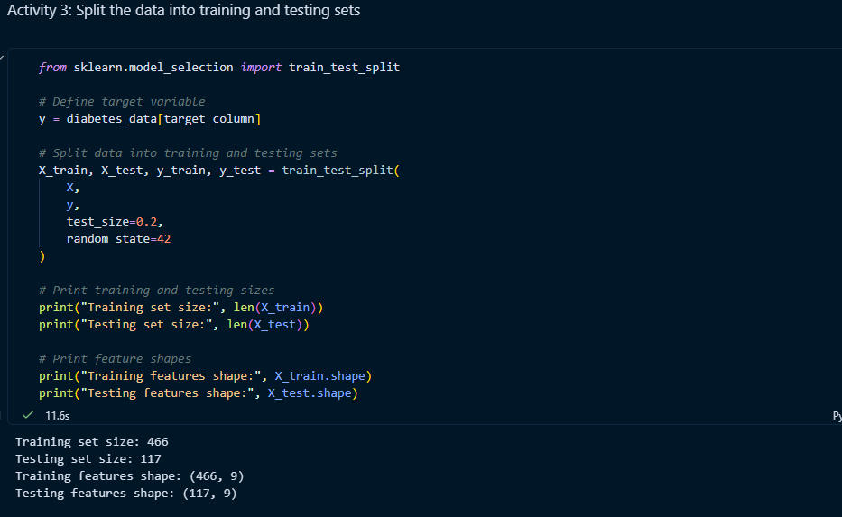

Task 3: Choose the classifier and train the model
Activity number | Activity name | Screenshot
1 | Choose the classifier (Use LogisticRegression):  - Print the chosen classifier name  - Print the reason for choosing it | 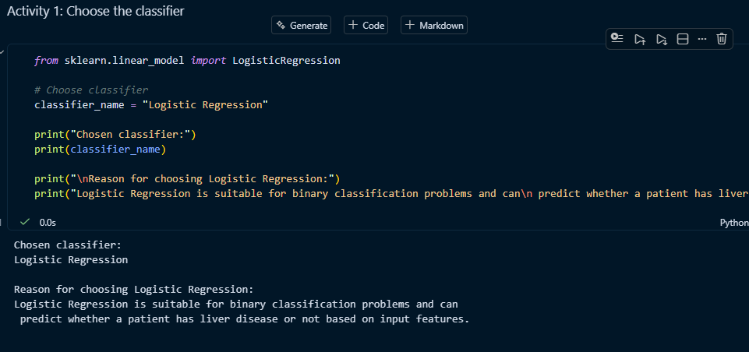
2 | Create the model:  - Display confirmation that model is created  - Print the model parameters | 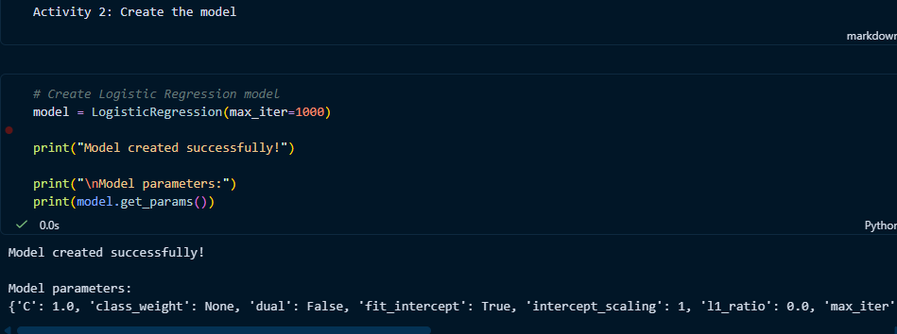
3 | Train the model  - Display confirmation that model is trained | 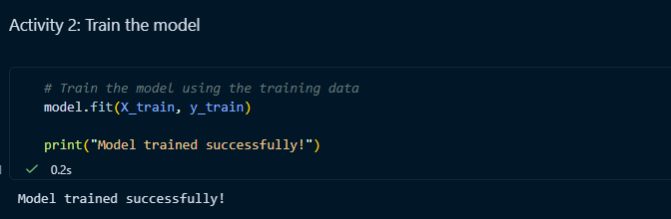

Task 4: Evaluate the model
Activity number | Activity name | Screenshot
1 | Calculate accuracy:  - Print accuracy score  - Print accuracy percentage | 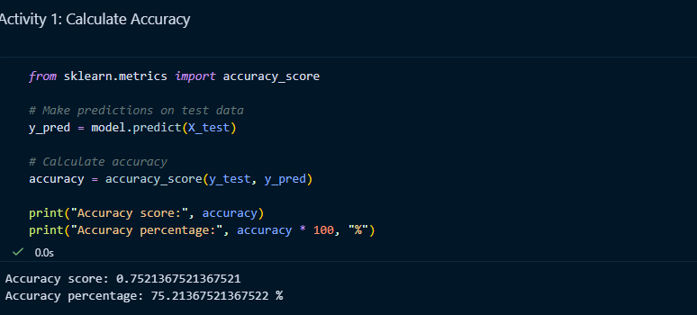
2 | Calculate sensitivity:  - Print sensitivity score  - Print sensitivity percentage | 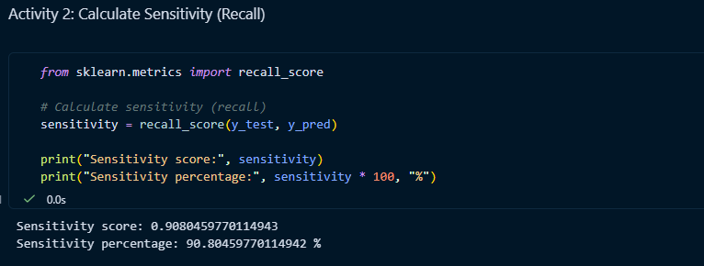
3 | Calculate specificity:  - Print specificity score  - Print specificity percentage | 